# P ROJECT DOCUMENTATION

P roject Title:

### P redicting the Energy Output of Wind T urbine Based on Weather Conditions W atson Auto AI

##### Internship

Title :

RSIP Career Basic ML 218

Project ID : SPS_PRO_298

NAME: SACHIN NAYAK

I NDEX

1. INTRODUCTION
   1. Overview
   2. Purpose
2. LITERATURE SURVEY
3. Exisfing problem
4. Proposed solufion
5. THEORETICAL ANALYSIS
   1. Block diagram
   2. Hardware / Sohware designing
6. EXPERIMENTAL INVESTIGATION
7. FLOW CHART
8. RESULT
9. ADVANTAGES & DISADVANTAGES
10. APPLICATION
11. CONCLUSION 10.FUTURE SCOPE 11.BIBLIOGRAPHY

APPENDIX

Source code

**I NTRODUCTION**

**O verview:**

As we all know that wind energy plays an increasing role in the supply of energy world-wide. Hence this project predicts the energy of the wind generated. The project is done with the help of IBM cloud. It consists of Watson studio Auto AI experiment which uses different pipelines and uses the best one. The prediction of the project is shown using Node Red App.

Auto AI feature of IBM cloud thus helps us to ﬁnd the best result and when we give the column name that we need to ﬁnd out the output it will go through the best suitable algorithm and gives us the result.

**P urpose:**

As we all know that the Wind energy plays an increasing role in the supply of energy world-wide. The energy output of a wind farm is highly dependent on the weather conditions present at its site.

If the output can be predicted more accurately, energy suppliers can coordinate the collaborative production of different energy sources more eﬃciently to avoid costly overproduction. So with the help of machine learning algorithm we can predict energy prediction based on weather data and analyse the important parameters as well as their correlation on the energy output.

# L ITERATURE SURVEY

E xisting Problem:

Most manufacturers rate their turbines by the amount of power they can safely produce at a particular wind speed.A wind turbine manufacturer can help us estimate the energy production you can expect. They will use a calculation based on the particular wind turbine power curve, the average annual wind speed at your site, the height of the tower that you plan to use, and the frequency distribution of the wind–an estimate of the number of hours that the wind will blow at each speed during an average year. If the wind speed decreases by half, power production decreases by a factor of eight. On average, therefore, wind turbines do not generate near their capacity that is why we need to predict the energy on different weather conditions so that it will help to boost the amount of energy.

### P roposed Solufion:

So to solve this problem Our aim is to map weather data to energy production. We wish to show that even data that is publicly available for weather stations close to wind farms can be used to give a good prediction of the energy output. Furthermore, we examine the impact of different weather conditions on the energy output of wind farms. We are building an IBM Watson AutoAI Machine Learning technique to predict the energy output of wind turbine. The model is deployed on IBM cloud to get scoring end point which can be used as API in mobile app or web app building. We are developing a web application which is built using node red service. We make use of the scoring end point to give user input values to the deployed model. The model prediction is then showcased on User Interface to predict the energy output of wind turbine.

**T HEORETICAL ANALYSIS**

#### B lock Diagram:



provide a data in csv ﬁle

Prepare data



Select model type

Generate and rank model

pipelines

save and deply the model

**H ardware Software Designing:**

We need a good internet connection in our computer System. Application browser is needed to open the IBM cloud.

## E xperimental Investigation

##### The ﬁrst step towards this project was to choose a topic.The topic was given by the platform.

* The second step was to look up Background Information about the topic given.I have used the dataset from kaggle and then read all the related infromation provided there.
* The third step toward this project to look upon my predictions that what can be my result and how can be the app at the end seems like.
* The next step was to analyse the data and collect

it.The data was in csv format which was easy to do things.The knowledge related to the cloud services

was needed to do this project.The steps and the node app in which the actual result should be predicted.

* The final step was to present the project which was done in the node app on ibm cloud in which we have access to our project from everywhere.

**F low Chart:**



* Data collecfion
* download the data csv ﬁle
* model building
  + import the dataset
    - run the model
* building and generafing and rank
* save and deply the model
* applicafion building
  + Create node red services
    - build ui with nodered
* ibm cloud
* create watson studio
* create cloud object storage
  + create ml service

**R ESULT**

After successfully done the deployment in the watson studio we have to present the project.So with the help of Node red app in the IBM cloud we did the steps as per required and the ui was hence generated.The Node Red UI provide us simple way to get the result of Auto AI Experiment. In this we need to give the inputs like date/time to predict the output.When you click on submit button it will give you the desired result.The following is the output which was generated by the application.

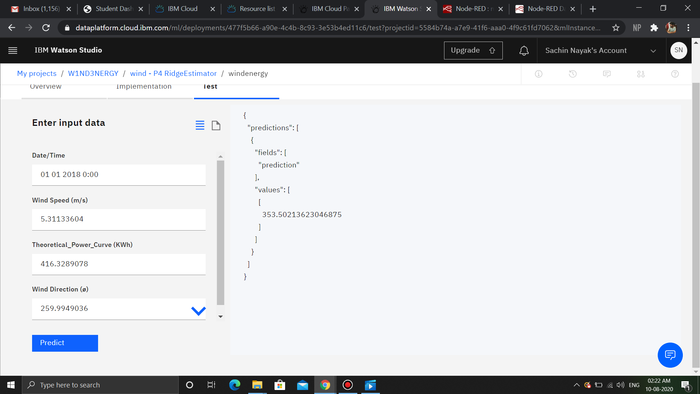

## A DVANTAGES:

##### Application is faster.

* It will give accurate result of the energy produced by the dataset.
* It is available 24/7.
* Automation is the major role and hence it is easy.
* Can be implemented as much as u want.

**D ISADVANTAGES:**

* There can be interpretation of the inputs the user will give.
* We need strong internet connection
* Time and resources.

**A PPLICATION**

We have examine the impact of different weather conditions on the energy output of wind farms through the dataset given. We have build an IBM Watson AutoAI Machine Learning technique to predict the energy output of wind turbine. Using The Auto AI Experiment, We can build and deploy a machine learning model with sophisticated training features and no coding. The tool does most of the work for you. In this project , the UI model building can help students a lot.With this feature our project is demonstrated in a better way.The predictions can be used in the impact of different weather conditions on the energy output of wind farms. The model is deployed on IBM cloud to get scoring end point which can be used as API in mobile app or web app building. We are developing a web application which is built using node red service which is available to use on other applications.

# C ONCLUSION

Hence we can conclude that we have made a model which predicts the output energy generated by the wind turbines at this speciﬁc weather condition through AUTO AI feature of IBM cloud.With the help of this Building of models faster because Auto AI prepares data, identiﬁes features, performs optimizations, and generates models much faster than humans doing the work by themselves.

Through this the Ranking and exploring of models by comparing the pipelines to determine the best model for the particular task. Deploying models was an easy task through Auto AI-generated pipelines. The deployed models can then be accessed and predictions can be are made.

## F UTURE SCOPE

With the enhancement of technology the growth of machine learning is also increasing and the AUTO AI feauture of IBM cloud provides a solution for a better and fast algorithms to deploy and give us the predictions.It will reduce the human efforts.With the help of this project it will give the predictions of the energy by the wind turbines at speciﬁc time.This model can be furthurmore can be used as API into the apps or websites.

# B IBLIOGRAPHY

* cloud.ibm.cloud
* [https://medium.com/ibm-watson/autoai-for-data-scientists-f rom-beginner-to-expert-cc6a93bb5c3b](https://medium.com/ibm-watson/autoai-for-data-scientists-from-beginner-to-expert-cc6a93bb5c3b)
* kaggle

**S OURCE CODE**

##### microsoft azure

* Aws